**WORD FILE II**

Maxim Gritsay

202 group

[Plot 1. Histograms combined in one line] 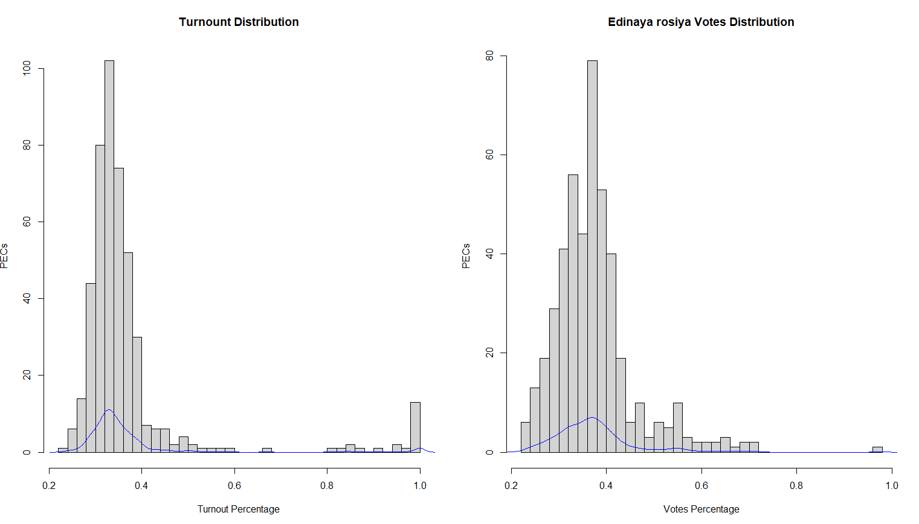

[Plot 2. Graph combining boxplots]

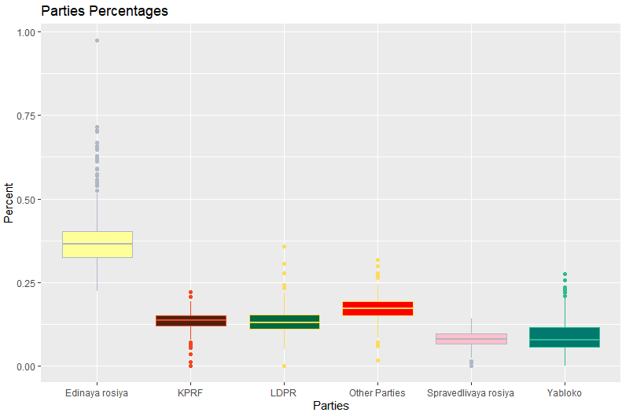

[Plot 3. 5 unified scatterplots]

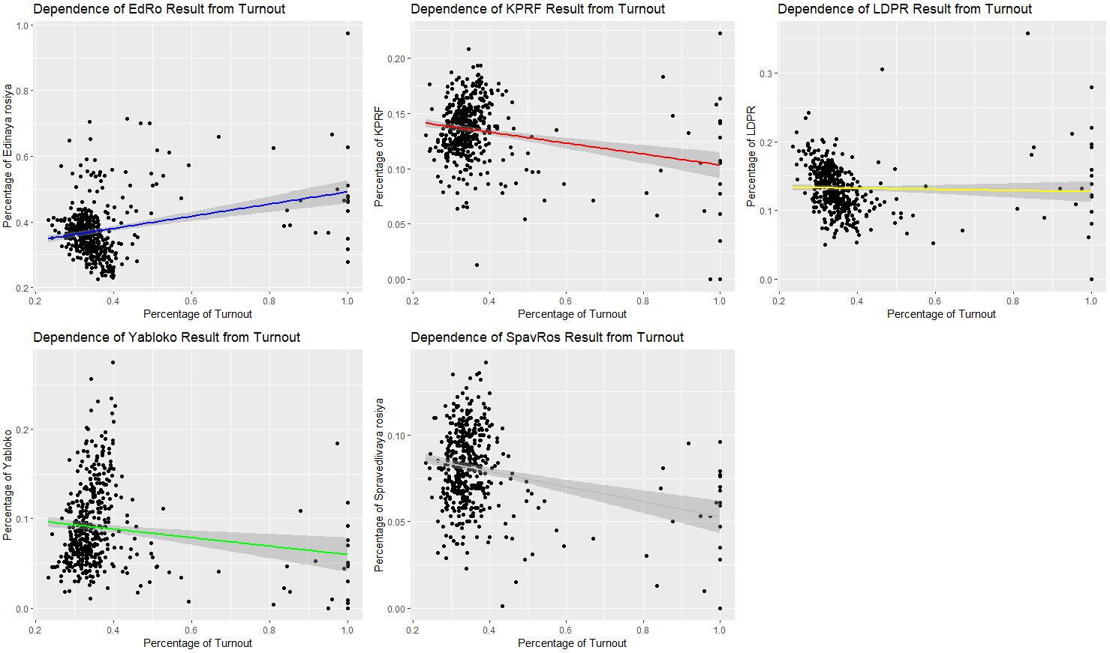

[Plot 6. Q-Q plot]

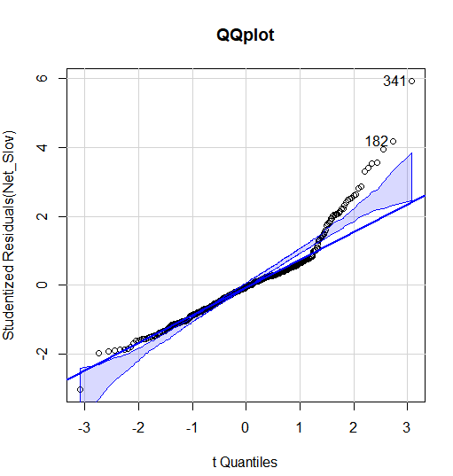

Brief interpretation: we can assume about the presence of problem because of points which are out of the confidence field

[Plot 7. crPlots]

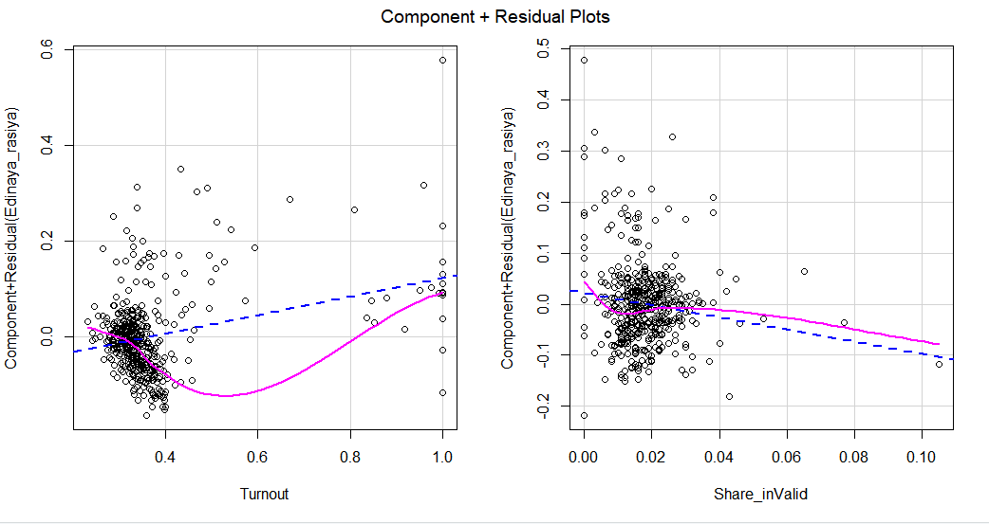

Brief interpretation: trendlines are not matching so there might be a problem of non-linear relationship between the IV and DV